Manual Changes by katherine.doty
4820-0053-2T DP ZEPHYR RENO, NV 6/10/2021 9:22:01 AM
LIST # L2-27 " LONG SPAN JOIST (SINGLE) " GRAY PRIMER
MARK QTY JOIST TYPE LENGTH BCP TONS WT/EA DEPTH TIME TC/BC JOIST STAMP
T77 6 33LH330/210 49-11 1/2 9 3.32 1106 33 26.947 3531/2018 6/10/2021 9:07:04 AM
6 3.32 26.947
*** MATERIAL REQUIREMENTS ***
SECTION (LEGACY) DESCRIPTION TONS CHANNEL FEET ANGLE FEET
C12BB (C12) 1.125 x 0.799 x .090 0.0230 70.750
C16BB (C16) 1.125 x 1.025 x .102 0.1097 248.250
C22BB (C22) 1.125 x 1.110 x .129 0.0508 83.750
C32BA (C32) 1.125 x 1.520 x .158 0.0915 96.875
C34AA (C34) 1.125 x 1.549 x .176 0.0352 33.375
C38BA (C38) 1.125 x 1.845 x .199 0.0590 42.875
2018 (19) 2 X 2 X .188 0.7157
302025 (69S) 3 x 2 x .250 0.0338
3531 (38) 3 1/2 X 3 1/2 X .313 2.1348
3.2535 575.875
*** COLOR CODE: Blue/Black ***
******************************* COVER NOTES *******************************
* WOODNAILER; SEE N1; 8" WIDTH *
* PROVIDE 1_ GAP BETWEEN TOP CHORD ANGLES, END CRIMP WEBS *
* DOUBLE PITCH JOISTS, SLOPES: 1/8:12 LE, 1/8:12 RE. DEPTHS: 30 LE, 30 RE *
* T77 - COPE TC 7/8 X 6 7/8 @ BE *
* T77 - VARIABLE PANELS *
***************************************************************************
PROVIDE 1" GAP BETWEEN TOP CHORD ANGLES, END CRIMP WEBS
Manual Changes by katherine.doty
4820-0053-2T DP ZEPHYR RENO, NV 6/10/2021 9:07:04 AM
V.2021.5.58.11
QTY JOIST TYPE MARK NO PAINT TIME (M-hrs)
6 33LH330/210 T77 GRAY PRIMER 26.75
LEFT RIDGE RIGHT
DEPTH END LINE END
2-6 2-9 2-6
TOTAL LENGTH TCXL < O-T-O > TCXR
49-11 1/2 0-2 3/8 49-11 1/2 0-2 3/8
LEFT WEB AT TC 0-7 5/8 CLEAR 0-6 7/8 CLEAR 0-6 7/8 RIGHT WEB AT TC 0-7 5/8
FILLERS: 0 in the END PANELS 0 in the INTERIOR
BOTTOM CHORD PANELS (OAL) LE= 4-6 3/8 RE= 4-6 3/8
BOTTOM CHORD PANEL LENGTH
PNL LENGTH PNL LENGTH PNL LENGTH PNL LENGTH PNL LENGTH
1 4-2 3/8 2 5-3 3 4-9 4 4-3 5 4-0
6 4-3 7 4-9 8 5-3 9 4-2 3/8
VARIABLE PANEL: LE #1= 1-5 3/8 + 2-9 RE #9= 2-9 + 1-5 3/8
BOTTOM CHORD CUTBACK FROM TOTAL LENGTH
BCXL(2)= 0-6 1/4 BCXR(2)= 0-6 1/4
SLOT
QTY DESC SECTION LENGTH TYPE DEPTH SETBACK SLOT SIZE GA
12 TC 3531 49-11 1/2
*** DOUBLE PITCH RIDGE LINE @ 24-11 3/4 SLOPES: 1/8:12 LE, 1/8:12 RE
12 BC 2018 48-11
12 BPL-L 302025 0-11 R 3 0-2 1/4 13/16 x 2 4
12 BPL-R 302025 0-11 R 3 0-2 1/4 13/16 x 2 4
QTY SECTION DESC USE LENGTH WELD TC BC DEPTH
6 C32BA W2L 1 4-7 3/8 3.53 x 0.158 0-4 3/8 4-6 3/8 2-6
6 C16BB V1S 1 2-9 7/8 1.08 x 0.102 3-2 3/8 4-6 3/8 2-6 3/8
6 C34AA W3L 1 2-9 3/8 1.60 x 0.176 5-11 3/4 4-6 3/8 2-6 3/4
6 C22BB W4L 1 3-7 3/8 2.55 x 0.129 5-11 3/4 8-8 3/4 2-6 3/4
6 C12BB V2 1 2-6 1/2 1.08 x 0.090 8-8 3/4 8-8 3/4 2-7
6 C38BA W5L 1 3-6 7/8 1.53 x 0.188 11-5 3/4 8-8 3/4 2-7 3/8
6 C16BB W6L 1 3-5 5/8 2.27 x 0.102 11-5 3/4 13-11 3/4 2-7 3/8
6 C16BB V3 1 2-7 1/8 1.00 x 0.102 13-11 3/4 13-11 3/4 2-7 5/8
6 C32BA W7L 1 3-5 1/2 1.26 x 0.158 16-5 3/4 13-11 3/4 2-8
6 C12BB W8L 1 3-4 1/8 1.76 x 0.090 16-5 3/4 18-8 3/4 2-8
6 C16BB V4 1 2-7 3/4 1.00 x 0.102 18-8 3/4 18-8 3/4 2-8 1/4
6 C22BB W9L 1 3-4 3/8 1.04 x 0.129 20-11 3/4 18-8 3/4 2-8 1/2
6 C16BB W10L 1 3-2 5/8 1.02 x 0.102 20-11 3/4 22-11 3/4 2-8 1/2
6 C16BB V5 1 2-8 1/4 1.00 x 0.102 22-11 3/4 22-11 3/4 2-8 3/4
6 C16BB W11L 1 3-3 1.00 x 0.102 24-11 3/4 22-11 3/4 2-9
6 C16BB W11R 1 3-3 1.00 x 0.102 24-11 3/4 26-11 3/4 2-9
6 C16BB V6 1 2-8 1/4 1.00 x 0.102 26-11 3/4 26-11 3/4 2-8 3/4
6 C16BB W10R 1 3-2 5/8 1.02 x 0.102 28-11 3/4 26-11 3/4 2-8 1/2
6 C22BB W9R 1 3-4 1/4 1.04 x 0.129 28-11 3/4 31-2 3/4 2-8 1/2
6 C16BB V7 1 2-7 3/4 1.00 x 0.102 31-2 3/4 31-2 3/4 2-8 1/4
6 C12BB W8R 1 3-4 1/4 1.76 x 0.090 33-5 3/4 31-2 3/4 2-8
6 C32BA W7R 1 3-5 1/2 1.26 x 0.158 33-5 3/4 35-11 3/4 2-8
6 C16BB V8 1 2-7 1/8 1.00 x 0.102 35-11 3/4 35-11 3/4 2-7 5/8
6 C16BB W6R 1 3-5 5/8 2.27 x 0.102 38-5 3/4 35-11 3/4 2-7 3/8
6 C38BA W5R 1 3-6 7/8 1.53 x 0.188 38-5 3/4 41-2 3/4 2-7 3/8
6 C12BB V9 1 2-6 1/2 1.08 x 0.090 41-2 3/4 41-2 3/4 2-7
6 C22BB W4R 1 3-7 3/8 2.55 x 0.129 43-11 3/4 41-2 3/4 2-6 3/4
6 C34AA W3R 1 2-9 3/8 1.60 x 0.176 43-11 3/4 45-5 1/8 2-6 3/4
6 C16BB V1S 1 2-9 7/8 1.08 x 0.102 46-9 1/8 45-5 1/8 2-6 3/8
6 C32BA W2R 1 4-7 3/8 3.53 x 0.158 49-7 1/8 45-5 1/8 2-6
STOP LEFT CENTER LEFT STOP RIGHT CENTER RIGHT V1S RIGHT
TC 8-8 3/4 24-11 3/4 8-8 3/4 24-11 3/4 3-2 3/8
BC 8-2 1/2 24-5 1/2 8-2 1/2 24-5 1/2
JOIST WEIGHT: 1106.20 CHANNEL FOOTAGE: 95-11 1/2
************** NOTES ***************
** T77 - COPE TC 7/8 X 6 7/8 @ BE **
** MAINTAIN 6 3/8 CLR BRG @ BE **
** WARNING TAG* **
Manual Changes by katherine.doty
4820-0053-2T DP ZEPHYR RENO, NV 6/10/2021 9:22:01 AM
LIST # L2-27 *** CHORD CUT SHEET *** ************************
* WOODNAILER; SEE N1 *
SECTION QTY LENGTH DESC MARK ************************
3531 12 49-11 1/2 TC T77
2018 12 48-11 BC T77
WOODNAILER; SEE N1
Manual Changes by katherine.doty
4820-0053-2T DP ZEPHYR RENO, NV 6/10/2021 9:22:01 AM
LIST # L2-27 *** WEB CUT SHEET *** ****************************************************
* PROVIDE 1_ GAP BETWEEN TC ANGLES, END CRIMP WEBS *
SECTION QTY LENGTH DESC MARK ****************************************************
C38BA 12 3-6 7/8 W5 T77
C34AA 12 2-9 3/8 W3 T77
C32BA 12 4-7 3/8 W2 T77
C32BA 12 3-5 1/2 W7 T77
C22BB 12 3-7 3/8 W4 T77
C22BB 12 3-4 3/8 W9 T77
C16BB 12 3-5 5/8 W6 T77
C16BB 12 3-3 W11 T77
C16BB 12 3-2 5/8 W10 T77
24 TOTAL PIECES
C16BB 12 2-9 7/8 V1S T77
C16BB 6 2-8 1/4 V6 T77
C16BB 6 2-8 1/4 V5 T77
12 TOTAL PIECES
C16BB 6 2-7 3/4 V7 T77
C16BB 6 2-7 3/4 V4 T77
12 TOTAL PIECES
C16BB 6 2-7 1/8 V8 T77
C16BB 6 2-7 1/8 V3 T77
12 TOTAL PIECES
C12BB 12 3-4 1/4 W8 T77
C12BB 6 2-6 1/2 V9 T77
C12BB 6 2-6 1/2 V2 T77
12 TOTAL PIECES
PROVIDE 1" GAP BETWEEN TOP CHORD ANGLES, END CRIMP WEBS
Manual Changes by katherine.doty
4820-0053-2T DP ZEPHYR RENO, NV 6/10/2021 9:22:01 AM
LIST # L2-27 *** BASE PLATE CUT SHEET ***
SECTION QTY LENGTH DESC MARK DEPTH SETBACK SLOT GA GOL
302025 12 0-11 BPL-L T77 3 0-2 1/4 13/16 x 2 4 1 3/16
302025 12 0-11 BPL-R T77 3 0-2 1/4 13/16 x 2 4 1 3/16
*** SUMMARY ***
302025 24 0-11 ---------------------------------- 0-2 1/4 13/16 x 2 4 1 3/16
JOB NAME: | DP ZEPHYR | DWG. BY: | CHK'D BY: | SHEET #:
LOCATION: | RENO, NV | KRD |  | N1 of 1
JOB #: | 4820-0053-2T
LIST: | L2-27 |  |  | TO SHOP

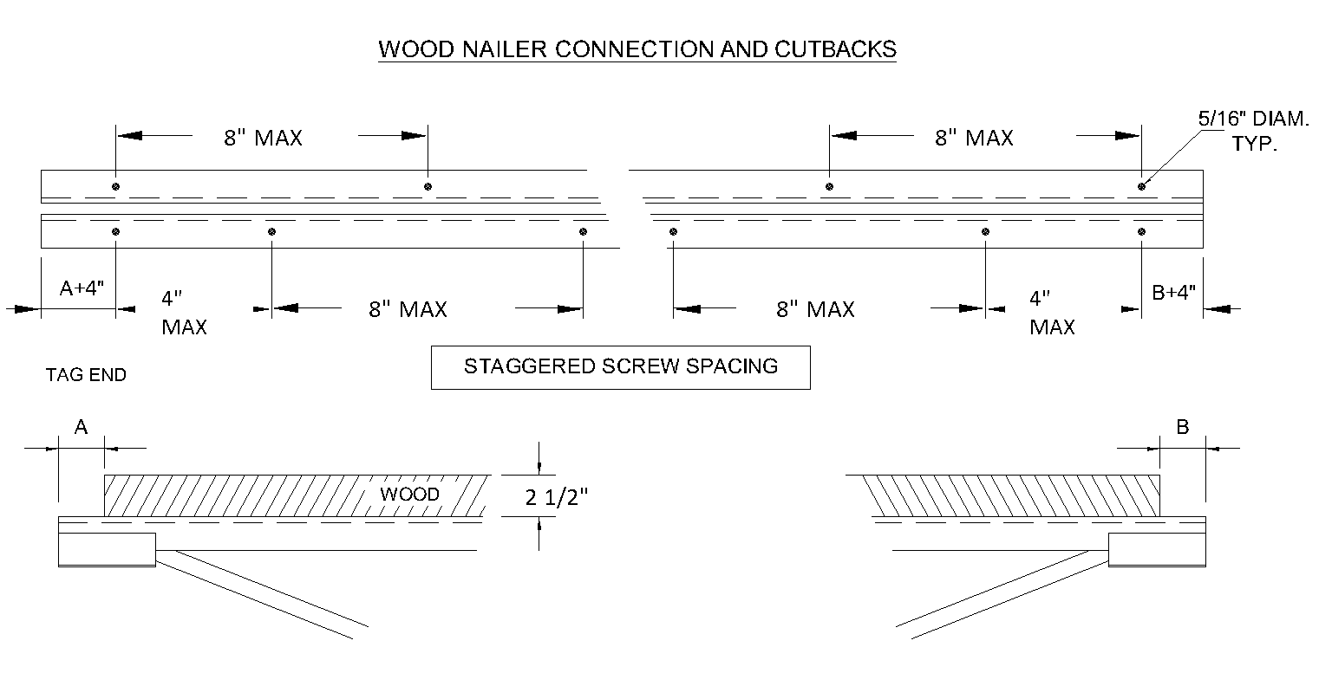
MARK(S) | QTY. | A | B | WOOD WIDTH  Panelized Inc. - No Mid-Span Joints | WOOD OAL | REMARKS
ALL | 6 | 1-3 | 1-3 | 8" | 47-5 1/2

